**ДАНА КЕНДЫБАЕВА LAB6**

**create database** lab6;  
**create table** employees(  
 **emp_id serial primary key**,  
 **first_name varchar**(20),  
 **last_name varchar**(40),  
 **salary int not null**,  
 **begin_date date**,  
 **end_date date**,  
 **job_title varchar**(50) **default ''**);  
  
**create table** department(  
 **department_id serial not null primary key**,  
 **emp_id serial references** employees(**emp_id**),  
 **department_name varchar**(5),  
 **email varchar**(40) **unique**,  
 **phone_number varchar** (12),  
 **hire_date timestamp with time zone**,  
 **commission float**);   
*--2***alter table** employees **add check** ( **end_date** >= **begin_date and begin_date** >= **'2000-01-01'**);  
*--3***alter table** employees **add constraint** chk_salary **check** ( **salary** > 65000 );  
*--4***alter table** employees **add unique** (**last_name**);  
*--5***alter table** employees **drop constraint** chk_salary;  
*--6***alter table** department **add constraint** foreign_key_con **foreign key** (**emp_id**) **references** employees(**emp_id**);  
**SELECT TABLE_NAME**, **COLUMN_NAME**, **CONSTRAINT_NAME  
FROM** INFORMATION_SCHEMA.KEY_COLUMN_USAGE **where constraint_name** = **'foreign_key_con'**;  
*--7***alter table** department **add check** ( **department_name** = **'FIT' or department_name** = **'BS' or department_name** = **'FEOG' or department_name** = **'FGGE'**);  
*--8***alter table** employees **drop emp_id cascade**;  
*--9***select first_name**, **last_name****from** employees **where last_name** > **'Fleming'**;  
*--10***alter table** department **add constraint** UC_dep **unique** (**email**);  
**alter table** department **drop constraint** UC_dep;

**select first_name**, **last_name from** employees;

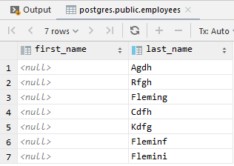

#6

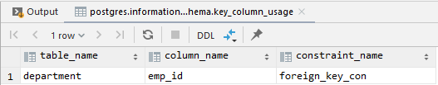

#9

